🏢 Mega Buildings & Data Centers Pitch
Utility-Grade Automation for Enterprise Facilities & Digital Infrastructure (10–50+ M SAR)
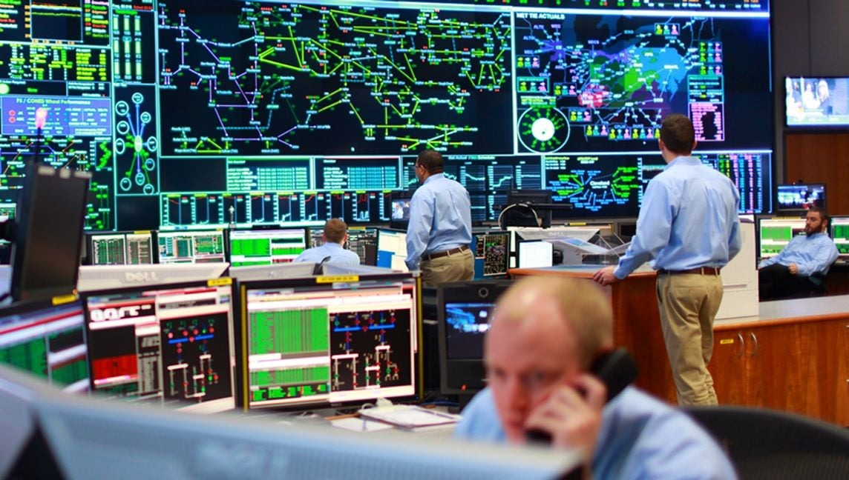
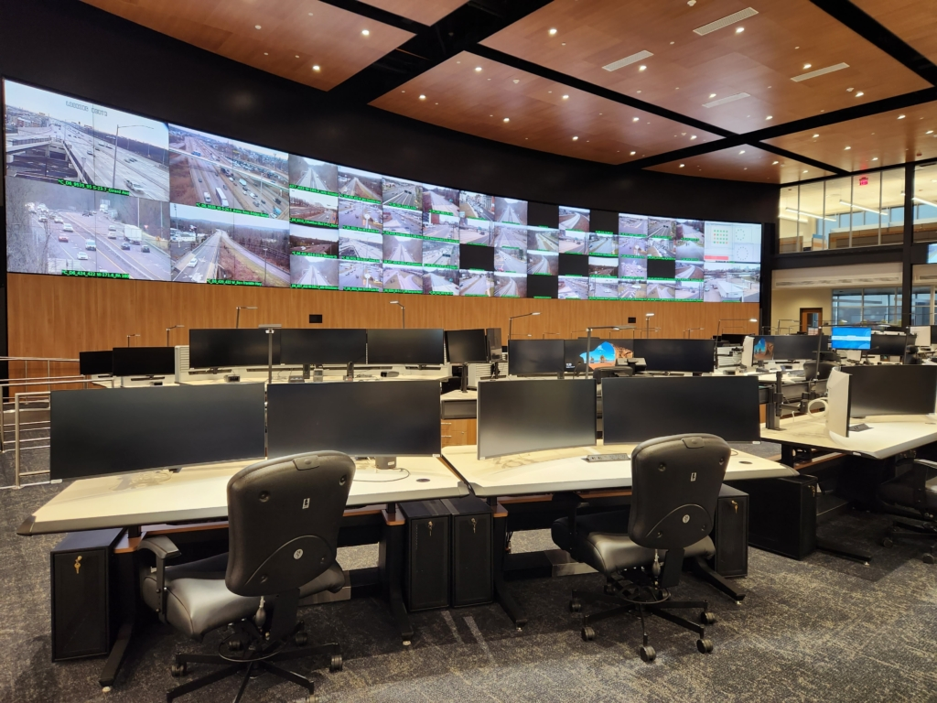
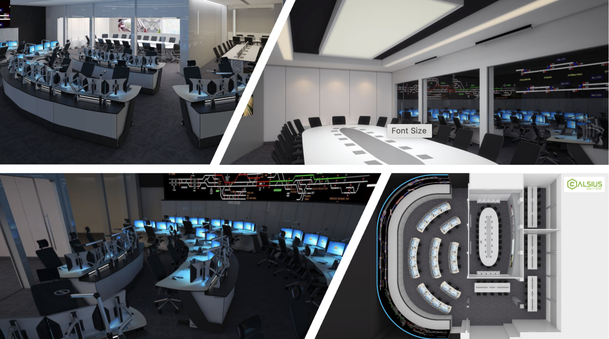
4

Executive Summary
Mega buildings and data centers are always-on enterprises. Downtime means financial loss, reputational damage, SLA penalties, and—in regulated environments—compliance exposure. Traditional BMS solutions focus on devices; they do not provide the operational rigor required for enterprise-scale facilities.
Mohammed Al-Ojaimi Energy Services – Automation Department delivers utility-grade operations platforms for mega buildings, campuses, and data centers, engineered with the same discipline used to operate national power grids—ensuring resilience, clarity, and long-term scalability.
We transform buildings into continuously operated digital assets.

The Challenge in Large Facilities
Owners and operators typically face:
- Fragmented systems (BMS, EMS, PMS, DCIM, security)
- Limited real-time visibility at campus or portfolio level
- Alarm floods without operational context
- Energy inefficiency and demand-charge exposure
- Weak disaster-recovery orchestration
- Vendor lock-in that limits future expansion
These gaps directly affect OPEX, uptime, and enterprise risk.

Our Enterprise Facility Automation Philosophy
We treat large buildings and data centers as critical infrastructure, not real estate.
Core Principles
- Operational continuity over aesthetics
- Single operational truth across all subsystems
- Deterministic behavior under fault conditions
- Cyber-secure, segmented OT architectures
- Lifecycle scalability measured in decades

Solution Architecture
A centralized Enterprise Operations & Command Platform built on COPA-DATA zenon, integrating all facility, power, and environmental systems into a secure, resilient environment.
Integrated Systems
- Electrical power & power quality (MV/LV)
- UPS, generators, ATS, STS
- Cooling systems (CRAC, chillers, HVAC)
- Energy meters & sustainability KPIs
- Fire & life-safety interfaces (monitoring layer)
- Physical security & access systems (integration layer)
- Data center infrastructure monitoring (DCIM integration)

Key Use Cases
🔹 Centralized Command & Control
- Campus-wide or multi-site dashboards
- Executive, operations, and engineering views
- Rapid incident detection and coordination
- SLA and uptime visibility
🔹 Energy Optimization & Demand Control
- Real-time energy profiling
- Peak shaving and load prioritization
- Cost-per-rack / cost-per-floor analytics
- Sustainability and ESG reporting
🔹 Resilience & Disaster Readiness
- Redundancy monitoring (N+1, 2N)
- Automated failover supervision
- Blackout and recovery sequence validation
- Incident replay and root-cause analysis
🔹 Scalable Portfolio Management
- Multi-building standardization
- Central governance with local autonomy
- Seamless expansion without re-engineering

Business Value (Executive View)
Impact Area | Typical Result
Facility Availability | >99.99%
Energy Cost Reduction | 10–20%
Alarm Noise Reduction | −50–70%
Incident Response Time | −40–60%
Lifecycle OPEX Reduction | Significant
This platform converts facilities from cost centers into performance-managed assets.

Why Al-Ojaimi Automation
- Proven utility-grade infrastructure expertise
- Deep understanding of power, redundancy, and failover
- Vendor-agnostic, future-proof design
- Strong OT networking & virtualization capability
- Single accountable partner for large-scale delivery

Project Profile
- Typical Budget: 10 – 50+ Million SAR
- Applications: Data Centers, Financial HQs, Airports, Mixed-Use Mega Developments
- Delivery Models: EPC / PMC / Direct Owner
- Project Duration: 12–24 months
We intentionally engage where engineering discipline outweighs lowest-cost procurement.

Our Commitment
- Zero-compromise reliability
- Clear, actionable operational intelligence
- Enterprise-scale scalability
- Long-term partnership and support

Call to Action
If your organization operates:
- Mission-critical facilities
- High-density digital infrastructure
- Large, multi-site building portfolios
We are ready to engineer the operational backbone of your enterprise.

